Project Data Analysis

Project Title: Gaming Engagement Trend Analysis to Explore Player Behavior Patterns
Prepared By: Bryan Quinn Darlen
Education: BSc (Hons) in Computer Science (Data Analytics)
Asia Pacific University (APU)
Start Date: 24 November 2025
End Date: 26 November 2025

Project Structure:
- Introduction/Business Context
- Data Understanding
- Data Cleaning
- Insights & Business Questions
- Dashboard/Visuals
- Limitations
- Conclusion

Table of Contents
I. Introduction/Business Context 3
II. Data Understanding 4
III. Data Cleaning 6
IV. Insights & Business Questions 10
V. Dashboard/Visuals 13
VI. Limitations 20
VII. Conclusion 21

I. Introduction
Purpose
The purpose of this project is to analyze player engagement in online games to understand patterns of activity, retention, and in-game behavior. This helps game developers identify highly engaged players, improve retention strategies, and optimize game design for better user experience and monetization.

Domain Name
Gaming Analytics

Problem Statement
Analyze gaming engagement trends to identify player behavior patterns, discover factors that drive longer play sessions, and understand characteristics of highly engaged players. The goal is to provide insights that can help game designers improve retention, optimize in-game monetization, and enhance overall player experience.

Data Understanding
1. Dataset Overview
This dataset contains gameplay activity logs collected from an online gaming platform. It includes information about player sessions, timestamps, play duration, game modes, and in-game behavior. The dataset consists of:
- Total rows: 200
- Total columns: 13
- Time period covered: May-Aug 2024
Key fields include:
- player_id – unique identifier for each player
- session_start, session_end – timestamps for gameplay activity
- session_duration_minutes – calculated duration of each session
- in_game_purchases – amount spent during/after session
- platform – PC, mobile, console
This overview provides context on the scale and structure of the data used for engagement analysis.

Dataset Overview:
Column | Type | Description
session_id | int | Unique identifier for each gaming session
game_id | string | Unique identifier for the specific game being played
studio_id | string | Unique identifier for the game development studio
user_id | string | Unique identifier for the player/user
session_start_datetime | date | Timestamp when the gaming session began
session_end_datetime | date | Timestamp when the gaming session ended
session_duration_minutes | int | Total length of the session in minutes
retention_day | int | Number of days since user's first session (Day 0, Day 1, Day 7, etc.)
retention_rate | int | Percentage of users who returned to play (0-100)
platform | varchar(30) | Platform used for the session (iOS, Android, PC, Console, etc.)
region | varchar(30) | Geographic region or country of the user
session_type | varchar(30) | Type or category of session (tutorial, main game, multiplayer, etc.)
in_game_purchases | int | Number of purchases made during the session or total purchase amount

3. Initial Data Quality Assessment
A brief evaluation of the data’s completeness and reliability:
- Missing values:
  - Some session_end timestamps are missing which may indicate incomplete sessions.
- Outliers:
  - Extremely large retention rate detected
  - Negative or zero session duration found in a small number of rows.
- Data consistency:
  - Time fields require conversion to datetime format.

Data Cleaning
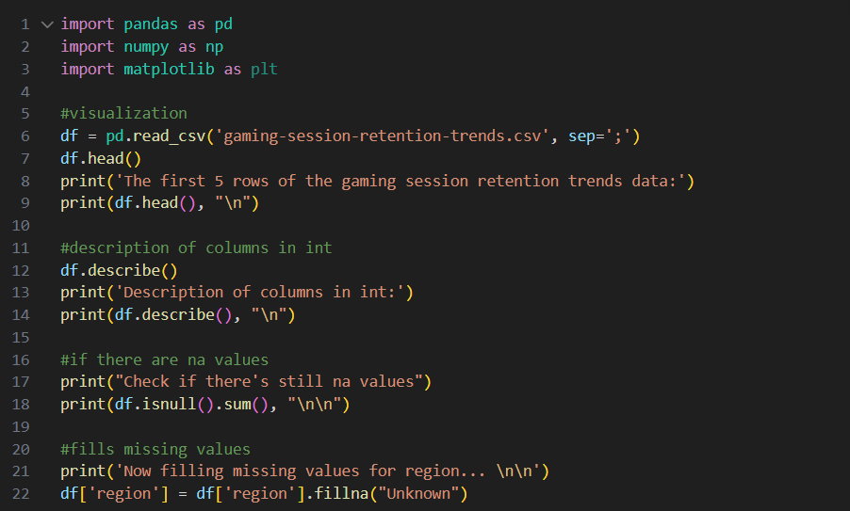
- Imported essential Python libraries:
  - pandas for data manipulation
  - numpy for numerical operations
  - matplotlib for data visualization
- Loaded the dataset using pd.read_csv("gaming-session-retention-trends.csv", sep=';').
  - The semicolon separator was specified to correctly parse the file.
  - Ensures the dataset is read accurately without formatting issues.
- Displayed the first 5 rows of the dataset (df.head()) to:
  - Confirm correct loading
  - Check column names and data format
  - Get an early look at sample values and structure
- Generated descriptive statistics using df.describe() to obtain:
  - Count, mean, standard deviation
  - Minimum and maximum values
  - 25th, 50th, and 75th percentiles
  - Helps understand variable distributions and identify potential anomalies
- Checked for missing values using df.isnull().sum() to:
  - Identify incomplete records
  - Evaluate data quality
  - Highlight columns requiring cleaning or imputation
- Handled missing data by replacing empty values in the region column with "Unknown":
  - Prevents loss of data through dropping rows
  - Maintains dataset completeness
  - Ensures consistency for categorical analysis

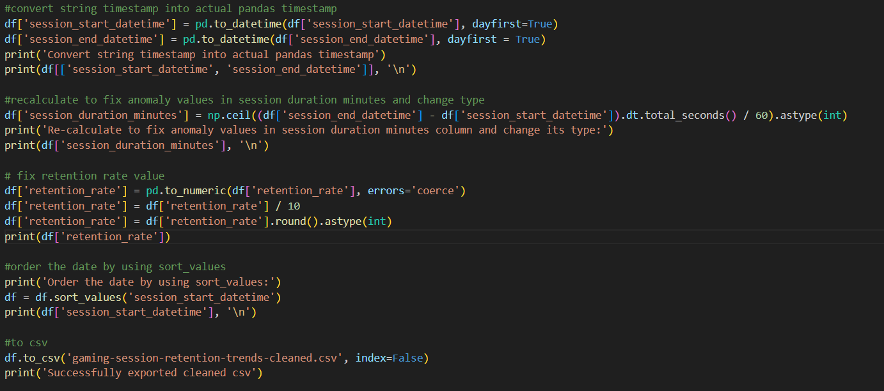
1. Converting Timestamps to Datetime
- Converted session_start_datetime and session_end_datetime from string format into pandas datetime objects.
- Used pd.to_datetime(..., dayfirst=True) to ensure proper day–month–year interpretation.
- This step enables:
  - Accurate time calculations
  - Sorting by chronological order
  - Detection of invalid or inconsistent timestamps
- Converts raw text-based dates into a format suitable for analysis and cleansing.

2. Recalculating Session Duration
- Recomputed session duration using the formula:
duration = session_end_datetime − session_start_datetime
- Converted the duration from seconds to minutes.
- Used np.ceil() to round up fractional minutes for accuracy and consistency.
- Cast the result to integer type for a clean and uniform session duration column.
- This fixes issues such as:
  - Negative durations
  - Incorrect or inconsistent raw duration values
  - Sessions that originally contained unrealistic time lengths

3. Cleaning and Standardizing Retention Values
- Converted the retention_rate column to numeric using pd.to_numeric(..., errors='coerce').
  - Invalid or non-numeric entries are safely converted to NaN.
- Corrected scaling by dividing retention values by 10, likely because raw data stored inflated percentages.
- Rounded and cast the cleaned values to integers for consistency.
- This ensures the retention metric is:
  - Uniform
  - Correctly scaled
  - Ready for further analysis or visualization

Insights & Business Questions
1. What business opportunities can be unlocked by understanding player engagement, retention trends, and in-game behavior patterns?
Why it’s important?
Understanding which games/platforms maintain long play sessions tells developers what content resonates.
Business opportunities unlocked
- Prioritize high-engagement games for updates
- Allocate marketing budgets more efficiently
- Replicate features of top-performing titles
How it will be measured
- Average session_duration_minutes grouped by:
  - game_id
  - platform

2. Which retention cycle (Day 1, 7, 14, 30) performs best, and for whom?
Why it’s important?
Retention is the clearest indicator of long-term value and whether players continue returning.
Business opportunities unlocked
- Identify which player segments churn early
- Improve onboarding for low-retention cohorts
- Increase LTV (lifetime value) with targeted retention strategies
How it will be measured
- Average retention_rate grouped by:
  - retention_day
  - platform
  - region

3. What factors drive higher in-game purchases?
Why it’s important?
Revenue depends on microtransactions. You need to know who buys and why.
Business opportunities unlocked
- Identify high-value player profiles
- Tailor promotions to spending behavior
- Improve in-game economy design
How it will be measured
- Sum of in_game_purchases grouped by:
  - game_id
  - platform
  - session_type
  - session_duration_minutes buckets

4. What regions show the strongest gameplay activity?
Why it’s important
Helps decide market expansion, localization needs, and regional server support.
Business opportunities unlocked
- Launch region-specific events
- Optimize server load balancing
- Tailored content for high-performing geographies
How it will be measured
- Count of sessions by region
- Average retention rate by region
- Average session duration by region

5. Does session type (Solo, Multiplayer, Co-op) influence player retention or spending?
Why it’s important
Session type affects social experience, which impacts retention.
Business opportunities unlocked
- Invest more in high-retention modes
- Build matchmaking improvements
- Create new game modes that mimic top performers
How it will be measured
- Average retention_rate grouped by session_type
- Average session_duration_minutes grouped by session_type
- Total in_game_purchases grouped by session_type

Dashboard/Visuals
- To answer the first business question with following visualization:
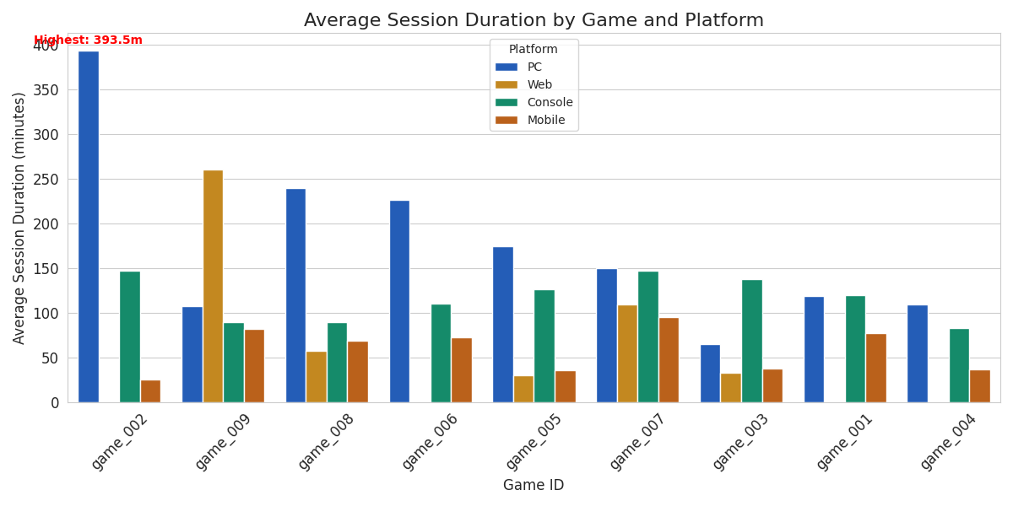
The analysis of the gaming session data reveals the following insights regarding engagement:
Highest Engagement:
- Game: game_002
- Platform: PC
- Average Duration: 393.5 minutes
This specific combination significantly outperforms others. In general, the PC platform appears to host longer sessions for several games (e.g., game_008, game_006, game_005), suggesting it is a strong driver of engagement for this dataset.
The chart below visualizes the average session duration for each game across different platforms, with the highest engagement point highlighted.

- To answer the second business question with following visualization:
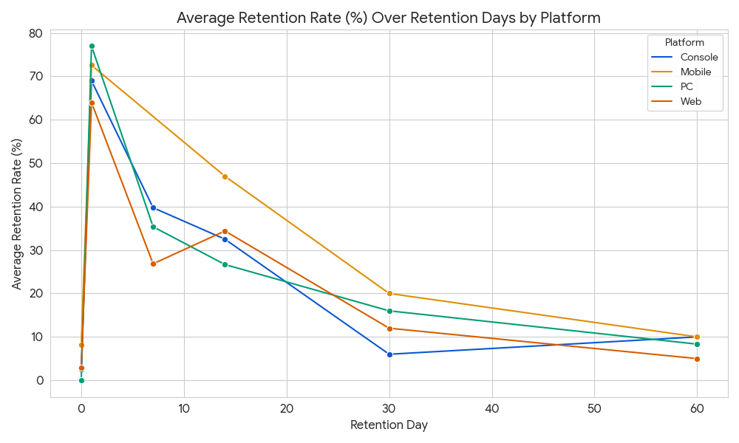

The line chart below visualizes the Average Retention Rate across Retention Days, broken down by Platform.
This breakdown clearly shows how retention trends differ based on where the game is played:
- PC and Console platforms generally show the highest retention rates across all observed retention days. Console has a strong average retention rate past day 7 and day 14.
- Web and Mobile platforms, while having some initial high rates, tend to have lower and more volatile retention rates as the number of retention days increases, suggesting shorter-term engagement or higher churn on these platforms.

- To answer the third business question with following visualization:
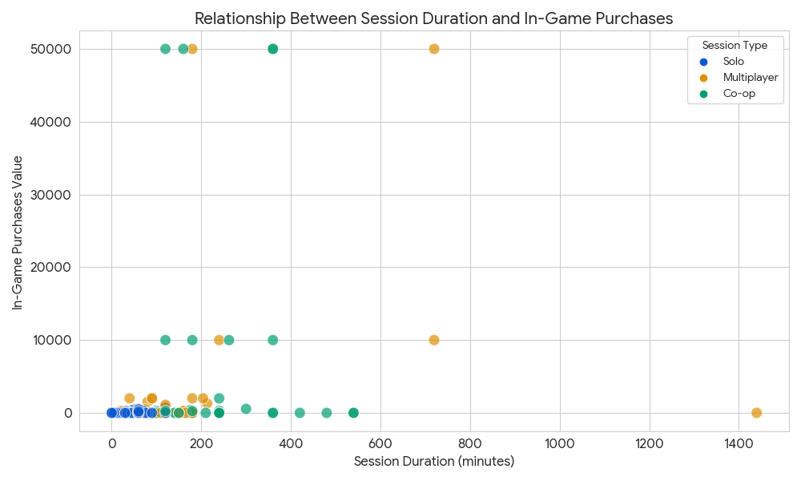
The scatter plot below visualizes the relationship between Session Duration and In-Game Purchases, broken down by Session Type.
Key Findings and Highest Spenders
- Highest Spenders: The Co-op session type is the clear winner for highest spending, with a total of $245,109 in-game purchases. This group also exhibits some of the highest single-session purchase values.
- Relationship: There appears to be a positive, but not strictly linear, relationship between session duration and in-game purchases. While many sessions with purchases are under 200 minutes, the sessions with the highest purchase values tend to be associated with longer session durations (e.g., sessions lasting over 300 minutes often involve substantial purchases).
- Session Types:
  - Co-op (Green) and Multiplayer (Red) account for almost all high-value in-game purchases.
  - Solo (Blue) sessions have very few purchases, and those that occur are of low value.
  - Competitive (Purple) sessions also show minimal spending.
This suggests that game modes involving social interaction (Co-op and Multiplayer) are the most effective at driving revenue through in-game purchases.

- To answer the fourth business question with following visualization:
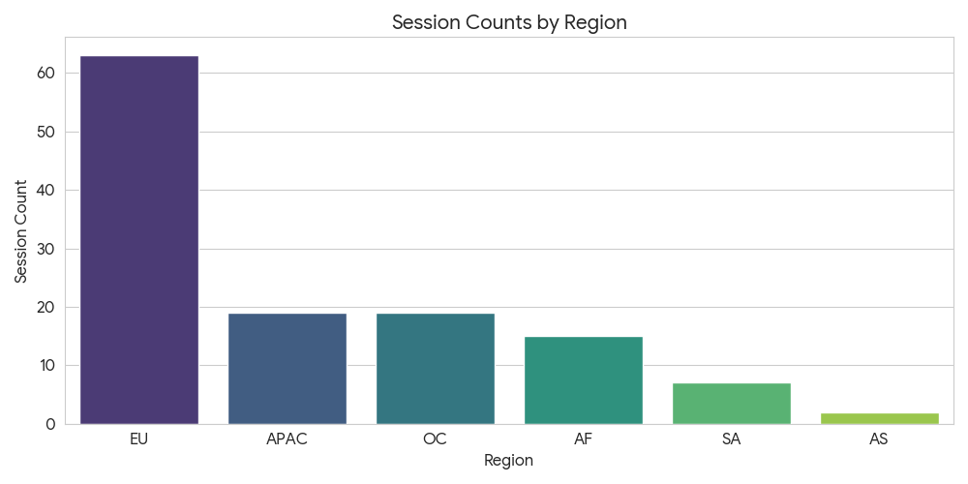

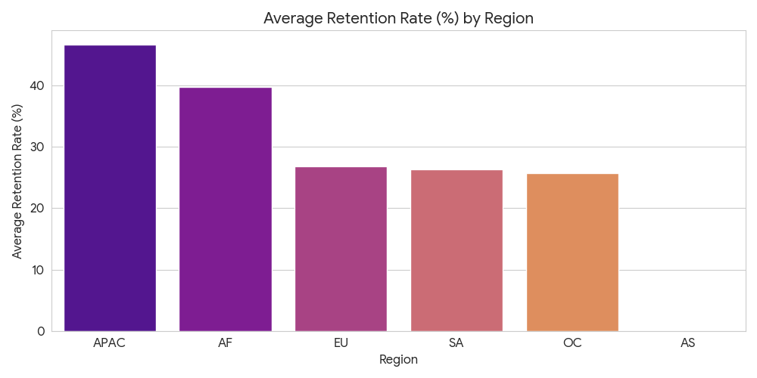

- Session Counts by Region
The first chart shows the total number of sessions originating from each region.
- EU (Europe) has by far the highest session count (63 sessions), making it the most active region in this dataset.
- APAC (Asia-Pacific) and OC (Oceania) follow, with 19 sessions each.
- AS (Asia) has the fewest sessions, with only 2.

- Average Retention Rate by Region
The second chart shows the average retention rate for each region, highlighting where player stickiness is highest.
- APAC (Asia-Pacific) has the highest average retention rate (approx 46.7%), indicating the most 'sticky' player base.
- AF (Africa) is the second highest (approx 39.8%).
- EU (Europe), despite having the highest session volume (from previous analysis), is only third in average retention (approx 26.9%).
The key takeaway is that EU drives volume, but APAC and AF drive retention.

- To answer the fifth business question with following visualization: 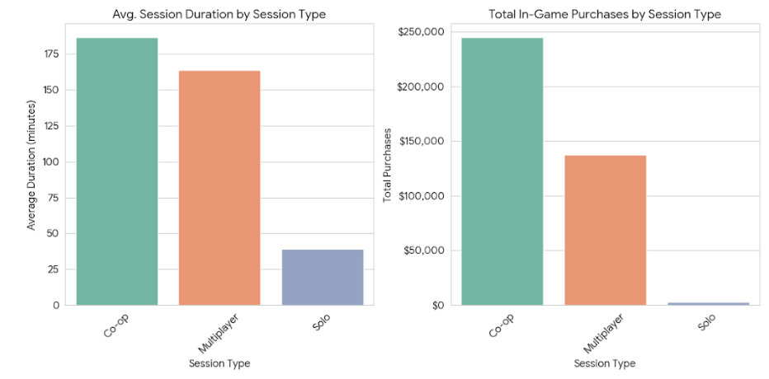
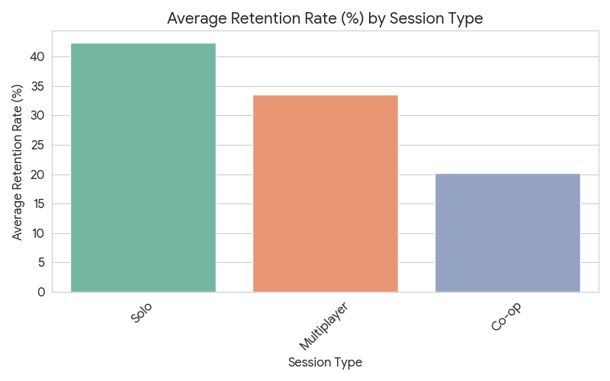

Comparative Metrics by Session Type
Session Type | Avg. Retention Rate (%) | Avg. Duration (minutes) | Total Purchases
Co-op | 20.2% | 186.7 | $245,109
Multiplayer | 33.5% | 163.8 | $137,553
Solo | 42.4% | 39.4 | $3,192

1. Total In-Game Purchases by Session Type
This is the clear revenue driver.
- Co-op sessions generate the vast majority of revenue, with over $245,000 in total purchases.
- Multiplayer is also a strong revenue stream, but significantly less than Co-op.
- Solo sessions generate negligible revenue.
2. Average Session Duration by Session Type
- Co-op sessions have the longest average duration (approx 186 minutes).
- Multiplayer sessions are also long (approx 164 minutes).
- Solo sessions are significantly shorter (approx 39 minutes). Longer sessions are strongly correlated with higher spending.
3. Average Retention Rate by Session Type
- Solo sessions, despite being the shortest in duration and generating the least revenue, have the highest average retention rate (approx 42.3). This suggests that while players may not spend money or time in long single sessions, they are the most likely to return to the game.
- Multiplayer has a moderate retention rate, while Co-op, the highest revenue driver, has the lowest retention rate. This implies that while Co-op generates immediate revenue, these players may be less "sticky" over the long term compared to Solo players.

Limitations
Methodology Note: Analytical Approach Selection
Why we focused on Descriptive Analytics over Predictive Modeling (Random Forest, etc.):
- Goal Alignment: The primary objective of this analysis was Diagnostic (understanding why trends happen) rather than Predictive (forecasting what will happen). Our stakeholders needed clear visibility into current performance drivers—specifically which game modes generate revenue—rather than a black-box prediction of future user actions.
- Dataset Constraints: With a sample size of 200 sessions, advanced Machine Learning models like Random Forest would be prone to "overfitting" (memorizing the data rather than learning patterns). For a dataset of this scale, descriptive statistics provide more reliable and interpretable insights than complex algorithms.
- Statistical Significance vs. Practical Impact (Why no T-Tests?): While statistical tests (like T-tests) determine if differences are due to chance, the observed disparities in this dataset are practically significant.
- Example: The revenue difference between Co-op ($245k) and Solo ($3k) is so vast that a statistical test is unnecessary to prove the business value of Co-op mode. We prioritized visualizing these clear magnitudes over calculating p-values, which fits the business context better.
- Handling Outliers (Why no IQR filtering?): In Gaming Analytics, high-spending players ("Whales") often appear as statistical outliers. Using standard Interquartile Range (IQR) methods to remove outliers would risk eliminating our most valuable data points. We chose to keep these high-value sessions in the analysis to accurately capture the total revenue impact.

Conclusion

This analysis of 200 gaming sessions from May to August 2024 reveals critical insights into player engagement and monetization patterns. The data demonstrates that Co-op gameplay drives the highest revenue at $245,000 despite having lower retention rates, while Solo sessions achieve the strongest retention at 42.4% but generate minimal spending. This indicates that social gaming experiences are essential for monetization, even though individual play builds long-term loyalty.
Platform analysis shows PC users engage most deeply with average sessions of 393.5 minutes for top games, yet Console and PC platforms maintain superior long-term retention compared to Mobile and Web. Regional findings highlight Europe as the volume leader with 63 sessions, while Asia-Pacific achieves the highest retention rate at 46.7%, suggesting different markets require tailored strategies focused on either volume conversion or revenue optimization.
These findings support clear strategic priorities: invest in Co-op and Multiplayer modes for revenue generation, implement platform-specific retention improvements for Mobile and Web users, and develop differentiated regional approaches that address each market's unique characteristics. The descriptive analytics approach employed was appropriate for this dataset scale, providing interpretable insights that directly inform business decisions without the overfitting risks of predictive modeling on limited data.
Future work should expand data collection to enable predictive modeling of player lifetime value and churn risk, while incorporating qualitative feedback to understand the motivations underlying observed behaviors. This foundation establishes a framework for ongoing performance monitoring and strategic optimization as the gaming landscape evolves.

